The original wireframe provided (located at relative path Documents/Wireframe.pdf) for part B was created without a clear understanding of the complete application workflow. As development progressed, it became clear that the initial design was too simplistic to support a smooth and intuitive user experience.
To address this, behavior was separated into different views. UI elements were added and removed to match the new workflow. This will be explained in more detail in the following sections, using screen shots to detail requirements and application flow.

Task C1
Term Interface shows terms and set dates with a date picker.
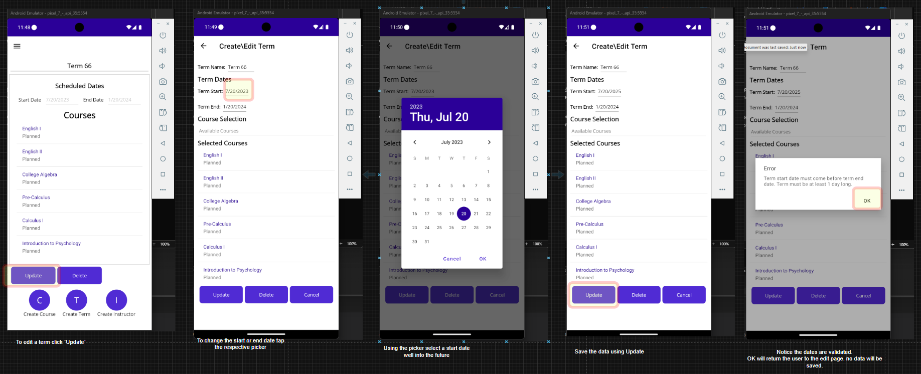

Task C2
Allow the user to add 6 course the will be displayed
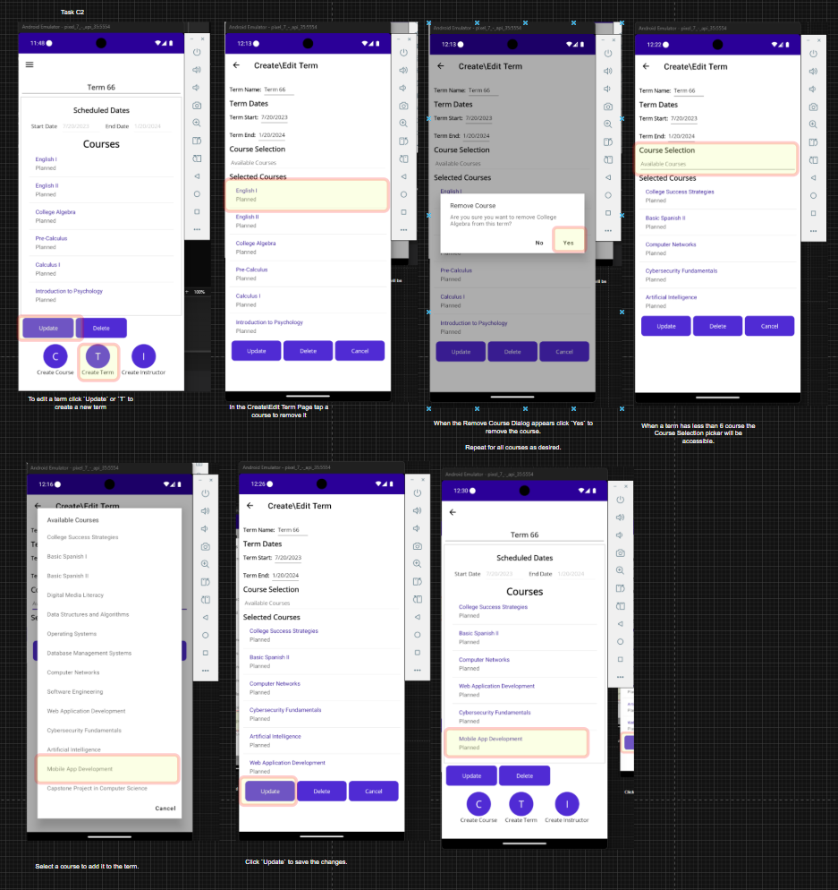
Task C3
Course interface, allow user to edit all details for a course, dates set with a date picker, validation of dates and null values
The user can create a new course or edit an existing course that is in a term.
Existing course name Validation
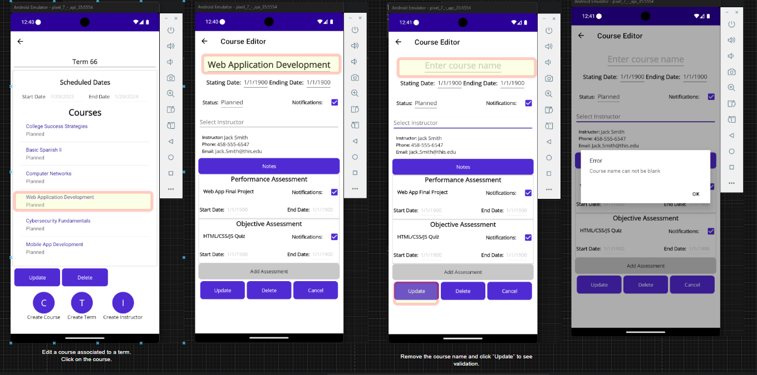

Course dates will be validated against themselves and if within the associated term
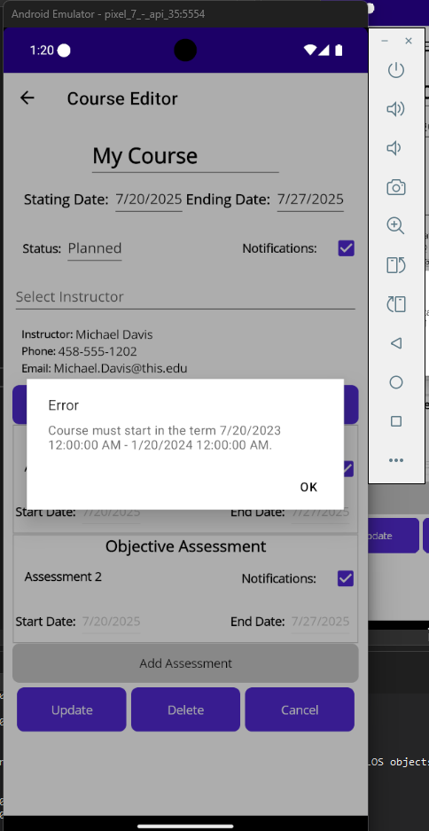
New Course Validation
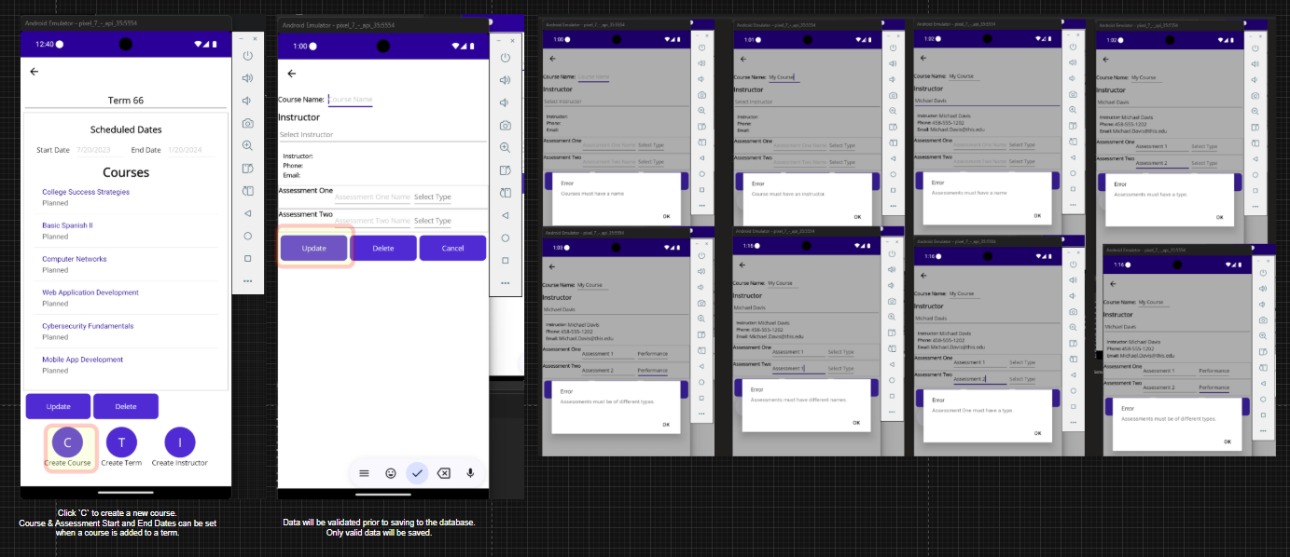

Task C4
For new course assessment entry refer to Task C3 new Course Validation
Update existing course assessments
Delete an assessment
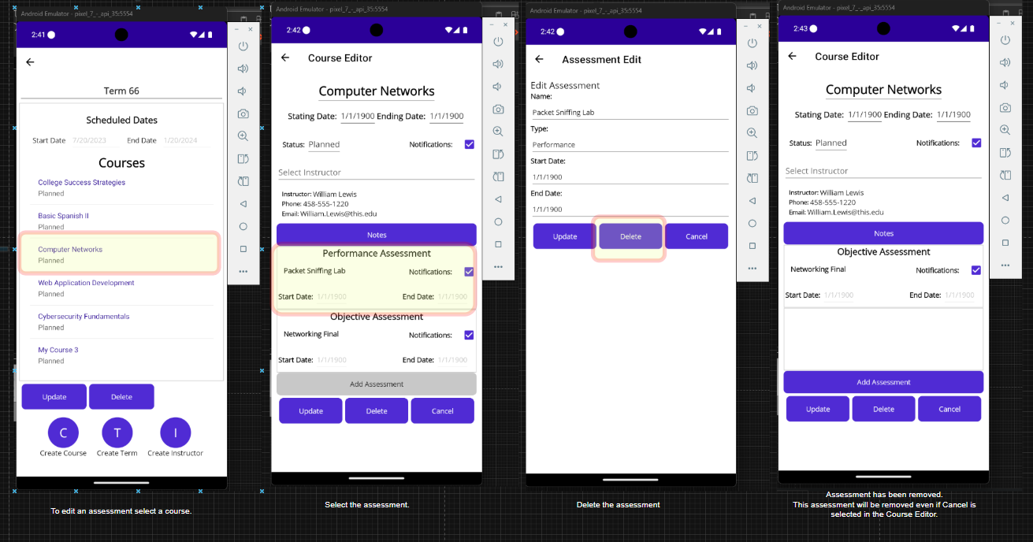
Edit an assessment
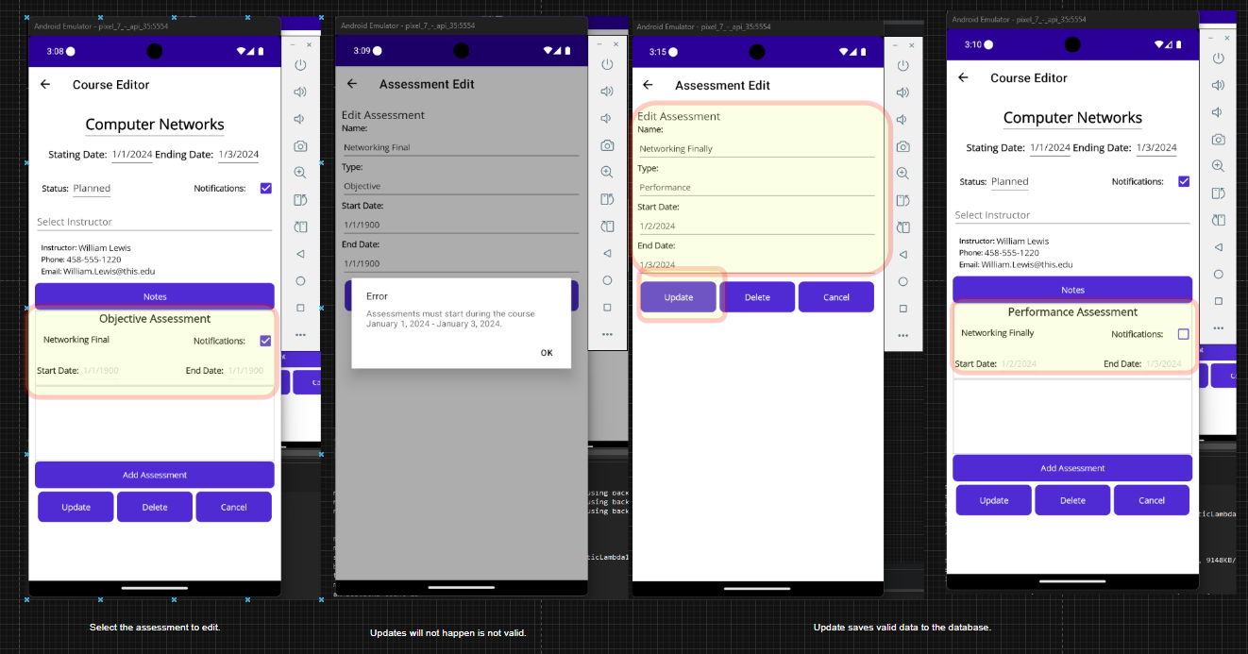

Task C5
Refer to Task C4 for details.
Task C6
Create a data set for evaluation
Data will be seeded for a new installation from respective .csv files.
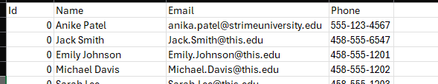
Data will show in Term 1 English 1
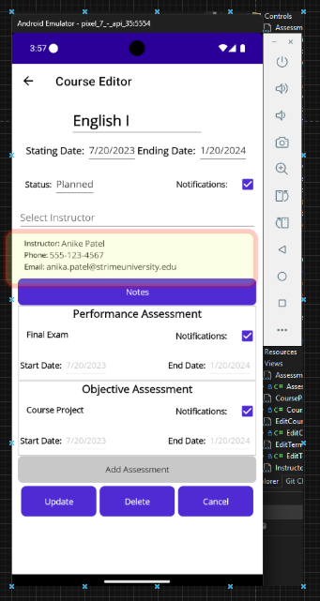

Other Defined Features
Course Notes
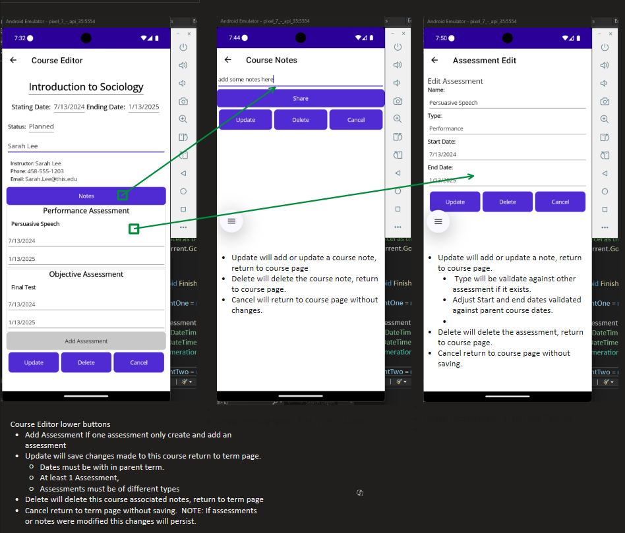

Note Sharing
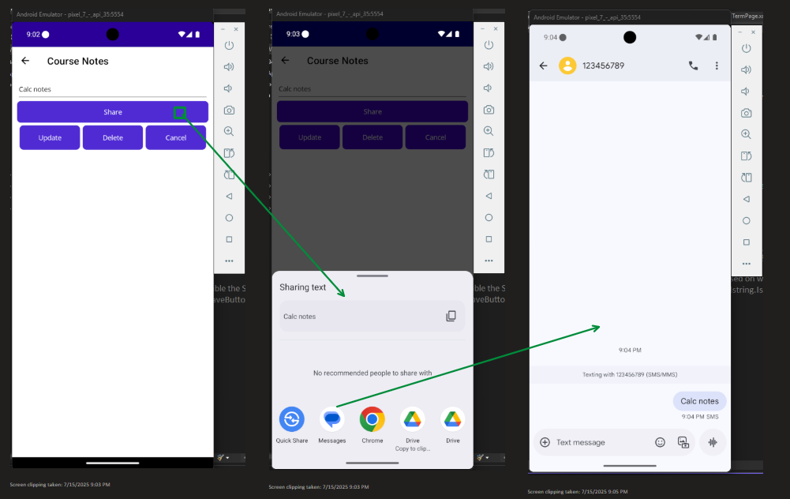

Notifications
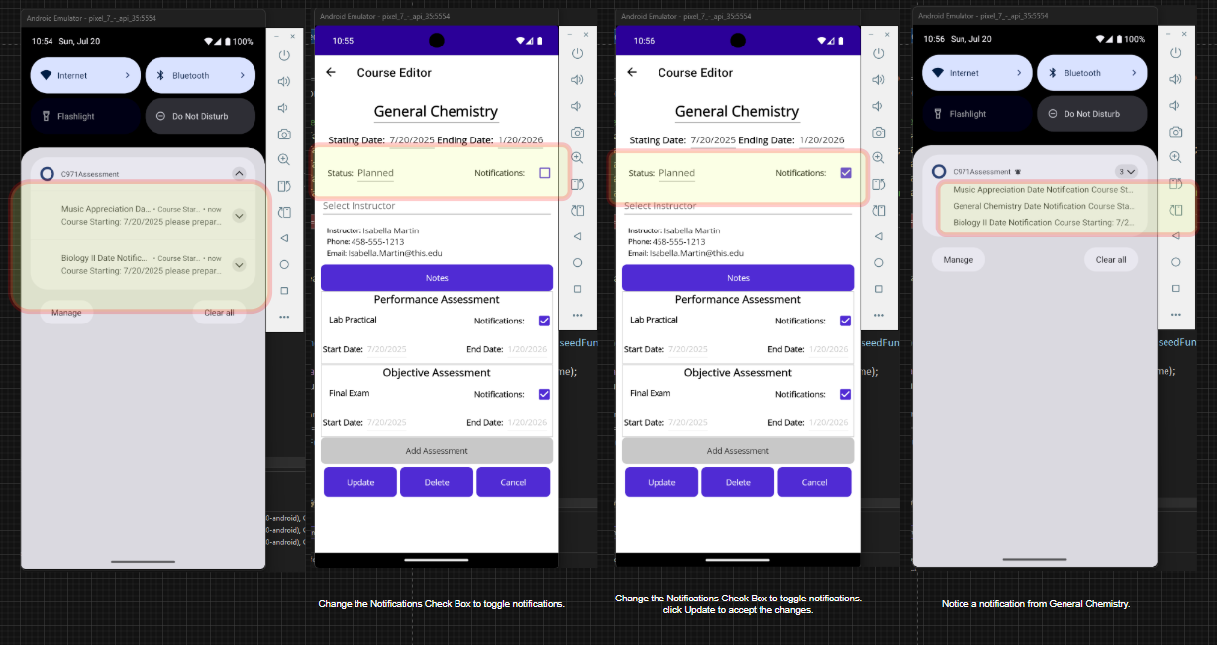
Note: Disabling notifications for a course will prevent related assessment notifications.

Git project repository path:
WGU GitLab Environment / Student Repos / ghamme3 / C971 Mobile Application Development Using C Sharp · GitLab

Commits
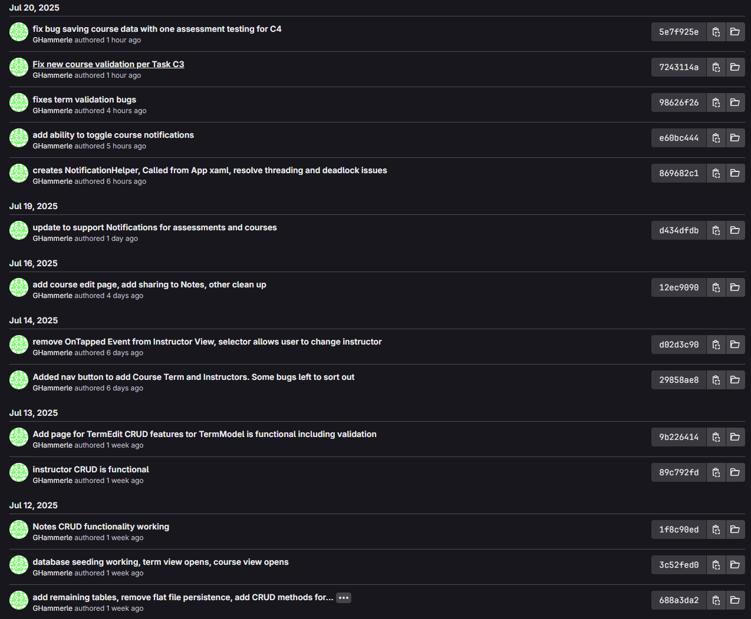
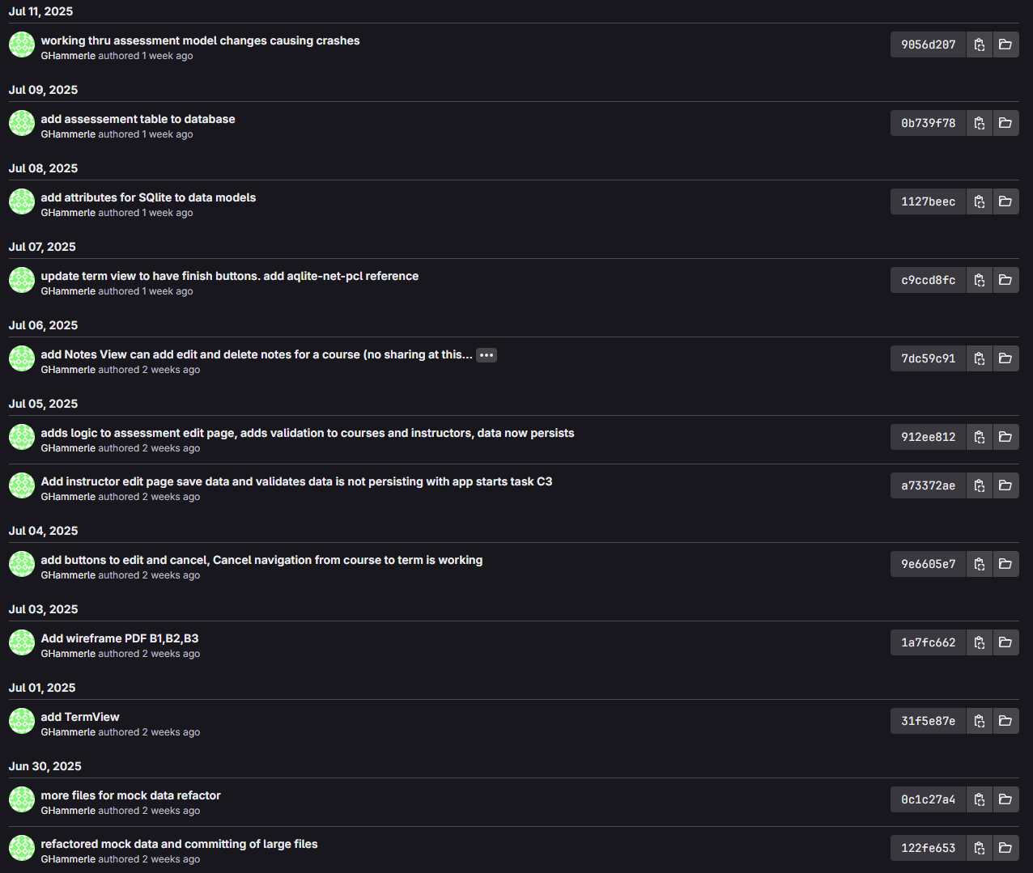
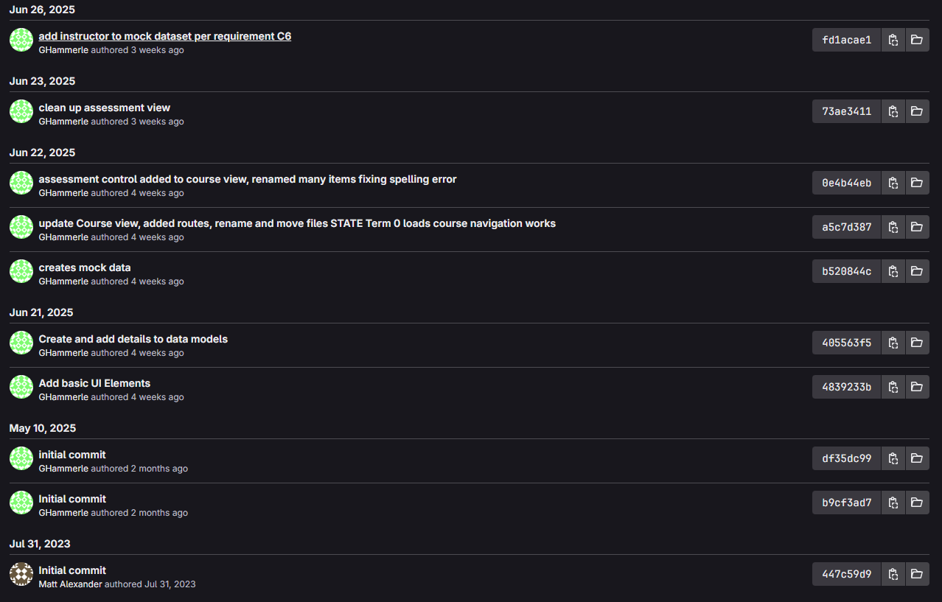

Revisions after Submission 1:

B2 Revisions

Initial wireframe did not include the ability to add or edit instructors
Initial wireframe and updated (initial) wireframe to include instructor page
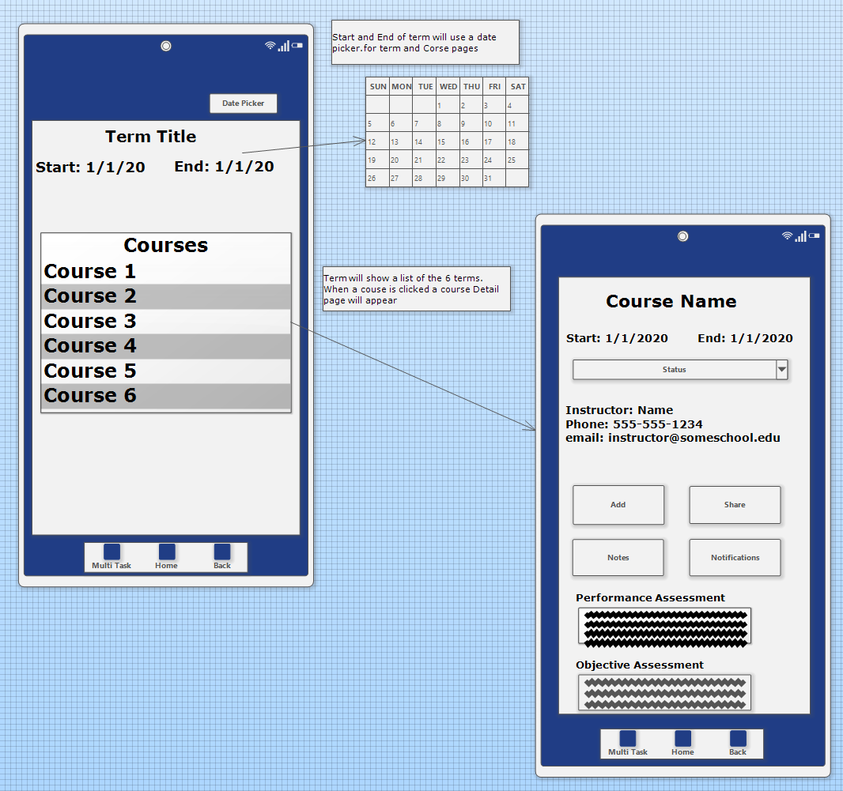 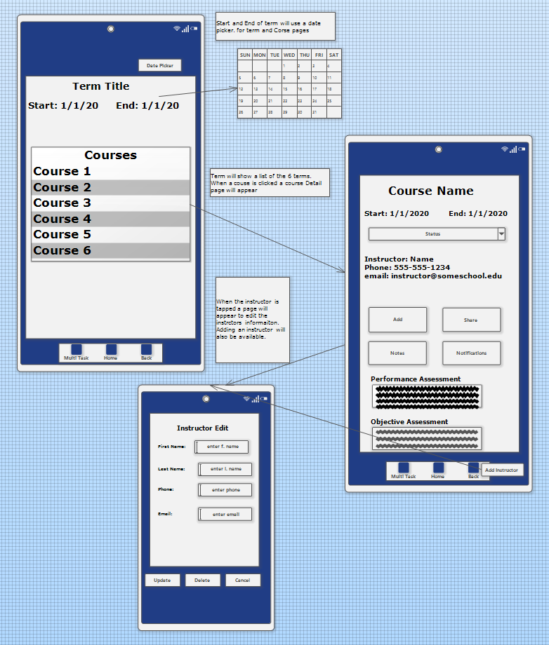

C4 Revisions

Assessment validation was not preventing the addition of assessments of the same type.
The validation check was not updated when the database for assessments was created. This logic has been updated and verified as working.
Courses were not being deleted and remained in a term. A method for deleting a course from the database was missing. This method was added and is called after removing assessments, notes and the course Id from the term. Verified as working.
End Date alert from course was not observed. If a course is active and the end date is within 7 days the user will be alerted. This was tested and verified working no code changes.
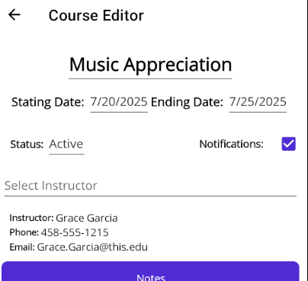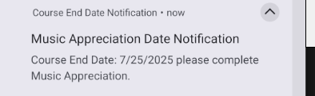

C5 Revision

Comment: Assessment Alerts were not observed
If Notifications are enabled and the course in Active notifications for assessments will happen.
An alert for Assessment is available if the current date is the start date or later and not within 7 days of the assessment due date.
An alert for assessment end will appear 7 days before the assessment due date.
This behavior is working as expected no code changes.
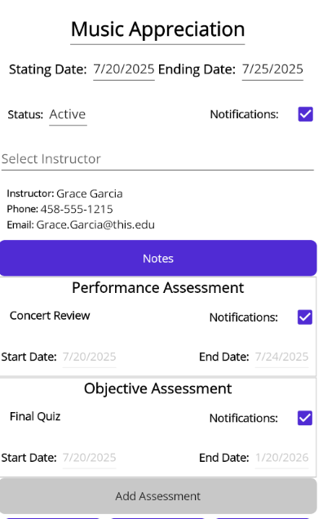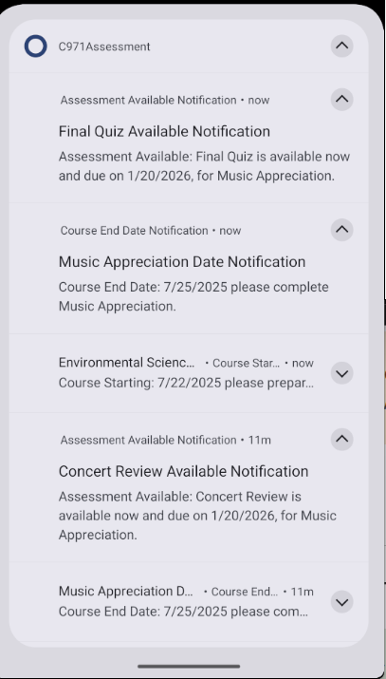

Code Changes for Revision
